**No path Qt Creator**

When I had an error in Qt Creator in Computer Graphics project I just cut and pasted project into different directory and it has started to work xD

Another time I just pasted shader folder to debug folder that is creating during compilation.

**Okay this is total random :O**

But what I did I created folder in the with random name “Buiul” in folder where project folder is located.

So this is path is to Buiul folder:

*C:\Users\a\Desktop\Dokumenty Wiktora\V rok\Computer Graphics\Buiul*

And path to project is:

*C:\Users\a\Desktop\Dokumenty Wiktora\V rok\Computer Graphics\GraphicsAssignment*

(P.S. it is not related with this problem but if you indicating path in Qt you are not using backslash (“\”) in paths but slash (“/) like that C:/glm/glm/gtx/transform2.hpp)

You need to indicate D folder path in Qt:

1. On the left hand side click Project and Build Directory indicate Buiul directory

It should looks like that:

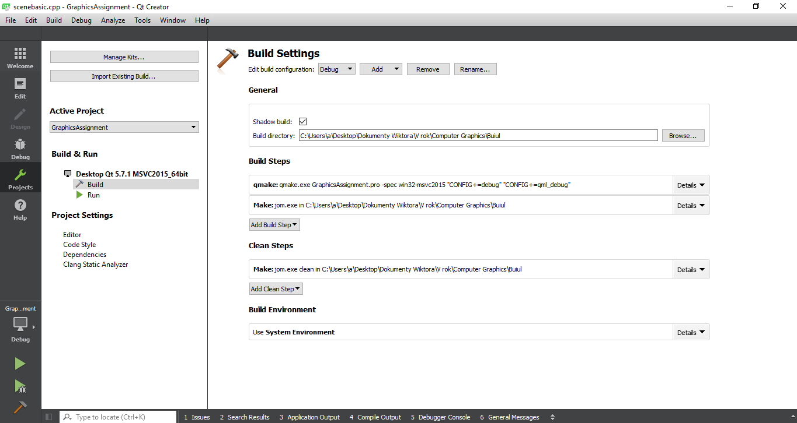

Add shader folder inside Buiul

Eventually turn off Anti-virus

And restart Qt Creator at the end!